1. **wireless networking (dance)**

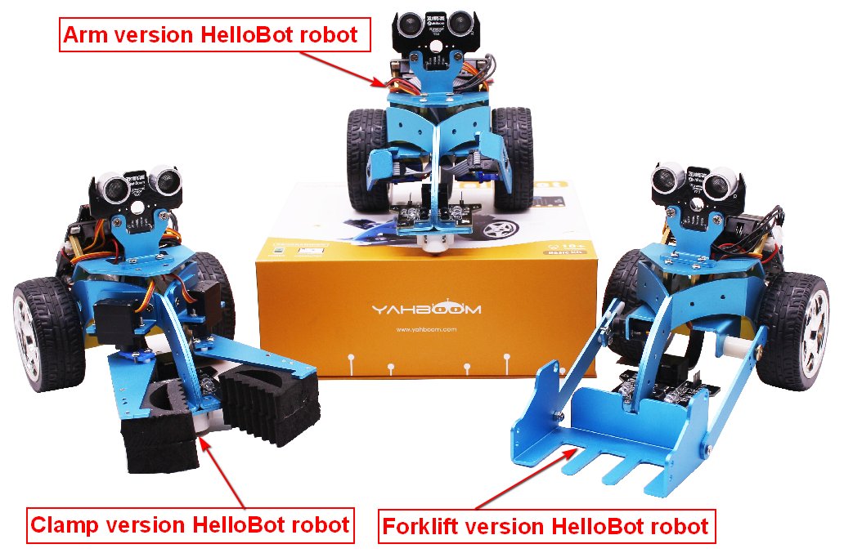

**1. Learning goals**

**1-1.Arm basic version code:**

The effect :

When multiple basic versionHelloBots is started, you can press “B” key of one of robots to make all robots dance with flashing lights and arm swing.

**1-2.Clamp version code:**

The effect :

When multiple clamp version HelloBots is started, you can press “B” key of one of robots to make all robots dance with flashing lights and arm swing.

**1-3.****Forklift version code:**

The effect :

When multiple forklift version HelloBots is started, you can press “B” key of one of robots to make all robots dance with flashing lights and arm swing.

**1-4.Arm basic/Clamp/Forklift version code:**

The effect :

When three different versions of the HelloBot are started, you can press “B” key of one of the arm version robots to make all robots dance with flashing lights and arm swing.

**Download programming:**

You need to make sure that the micro:bit development board is connected to the computer. Then you should click on the download in the lower left corner as shown in P 4-1 to download the program to micro:bit.

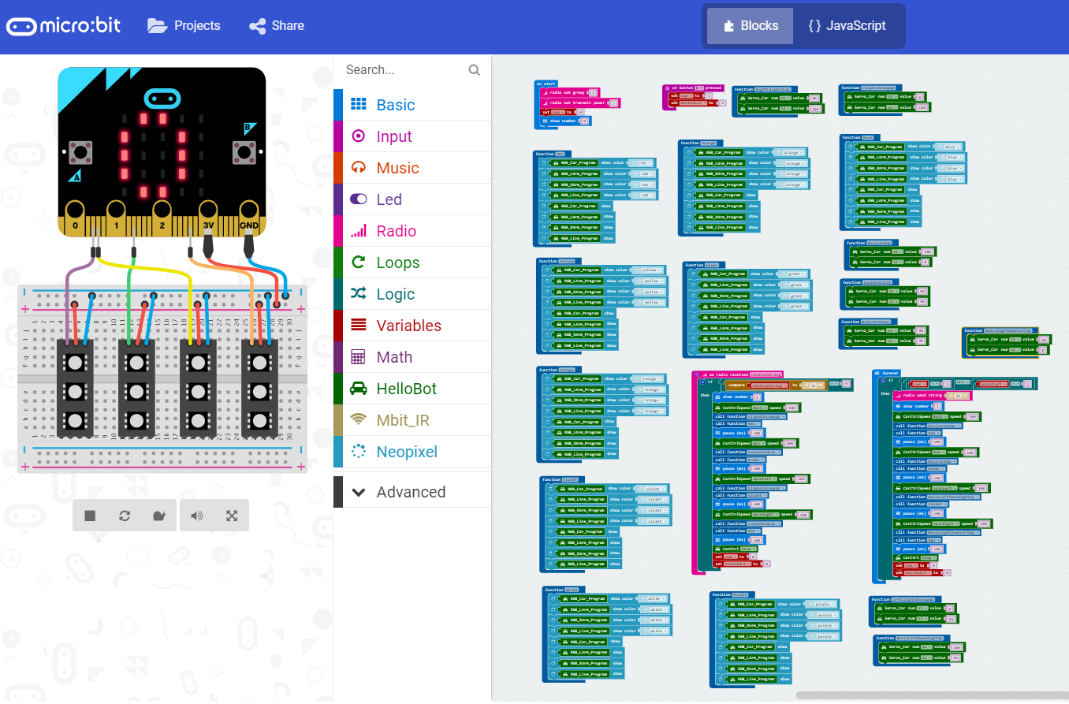

4-1

**5.Phenomenon**

The video recorded in this lesson is to use the arm version hellobot, the clamp version hellobot, the forklift version hellobot. We need to download code to all the HelloBot cars.

**【wireless networking dance(Arm basic_Clamp_Forklift).hex】**

When the download is complete, we need to start all HelloBot cars, **and press the “B” button of the arm basic version of the HelloBot cars.** You can see that all robots start to dance, complete the front, back, left and right four movements with swinging arms and flashing lights. When these actions are completed, you also can **press the “B” button of the arm basic version of the HelloBot cars again** to continue dancing.

Since the speed of the car is proportional to the voltage, the inconsistent voltage will cause the speed of the car to dance differently. It is recommended to fully charge the car before the experiment to ensure the speed of the car is consistent. In addition, the two motors of the car can't guarantee that the speed is absolutely consistent. If the car can't travel straight, you can change parameters of the two motors in the program.

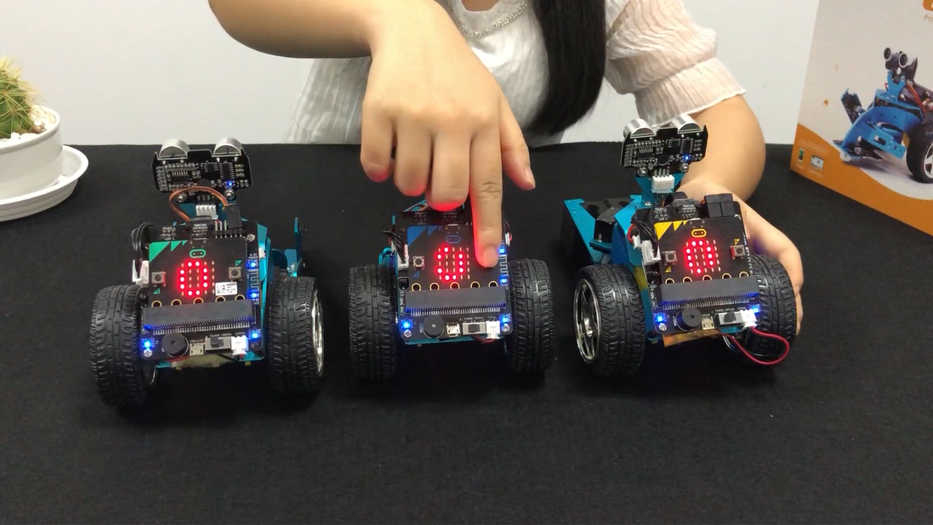

4-2

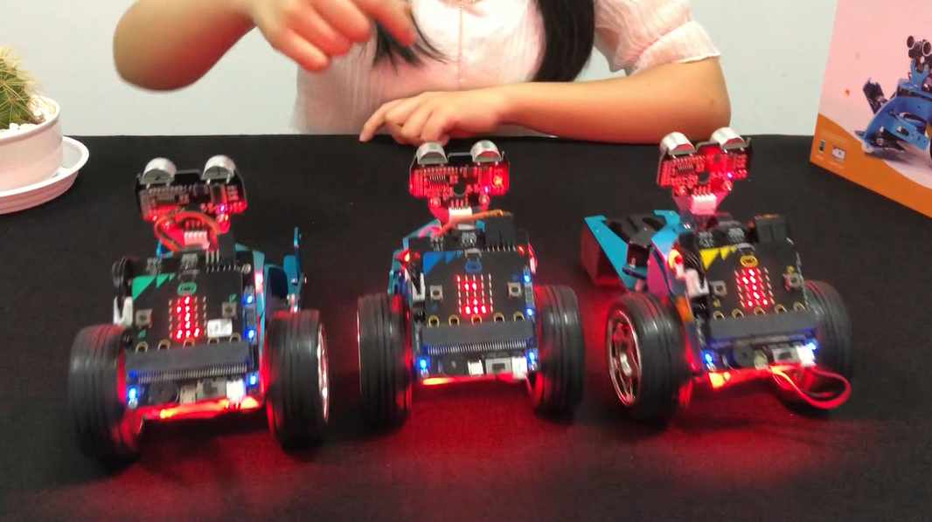

4-3